7.1.9
Details of activities that inculcate values; necessary to render students into responsible citizens:
Dharmendrasinhji Arts College arranges all possible initiatives in organising a number of programmes and events for making the learners and faculty members to become responsible citizens of the nation by sensitising them to the constitution of the country.

With a view to becoming the responsible citizens of our nation, the students of Dharmendrasinhji Arts College, Rajkot are motivated to participate in different activities of the college.
Our college encourages the students to take part in digital events organised in college for them that make them understand the importance of protecting the cultural heritage of the country.
The college has also arranged Expert Talks on the Indian Constitution where subject experts delivered the lecture about the importance of the Indian constitution and how we should do work in the direction of saving our constitution.

The Expert talks were also conducted to focus on enlightening the students about their rights and duties being the responsible citizens of the country.In year 2020-2021 such events were conducted on the digital platform.

Singing of the national anthem in the campus on every special occasion so as to bring a feeling of nationalism among all.

15/08/2020
Independence Day
On Saturday at 7:30am on 15th August, 2020 Dharmendrasinhji Arts College, Rajkot celebrated Independence Day. The function was handled by Dr. H.j. Gohil. Independence day is also celebrated each year to highlight the struggle of freedom and the importance of the Indian constitution.

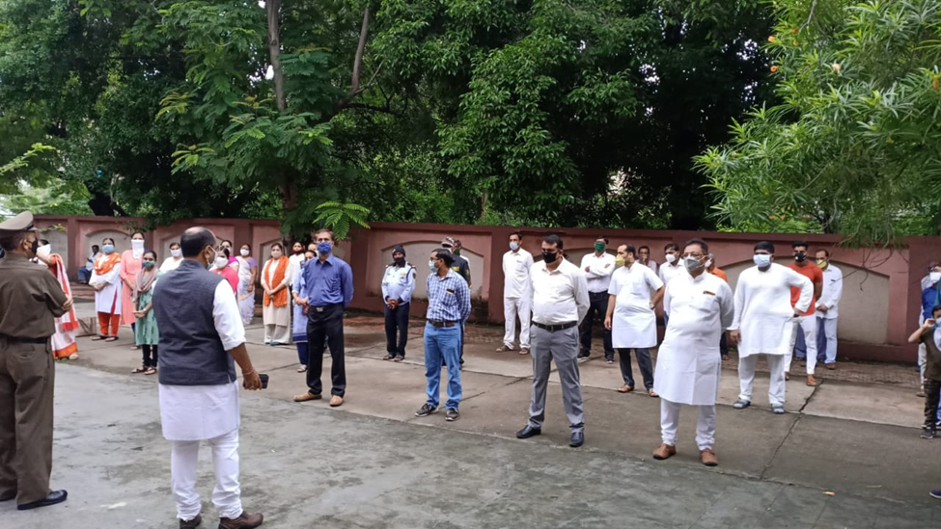

26/11/2020
Bandharan divas

Dharmendrasinhji Arts College, Rajkot conducted an online program on 26/11/2020 at 1:15pm on Microsoft Teams. This day is known as the National Constitutional Day and National Lay Day. Students of our college became aware about the importance of the Indian Constitution was the motto behind organising this digital venture. Dr. A. S. Rathor - the principal and Mr. Aswin Punjani - the senior faculty of our college gave very informative sessions on the history and importance of Indian Constitution. All the students of the college attended this virtual function. At last the quiz was designed by Dr. B. B. Kachhadiya and Mr. Aswin Punjani on Indian Constitution. Many students also participated in this online quiz.

26/11/2020
Bandharan divas
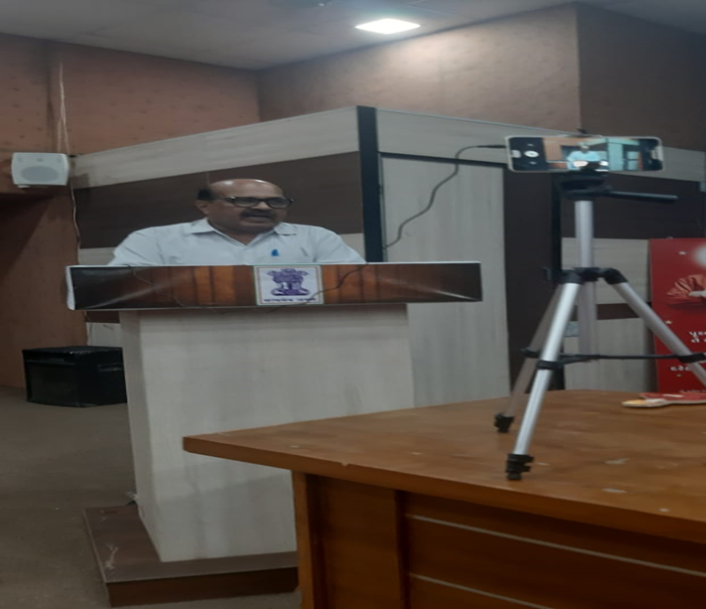

10/12/2020
Manav Adhikar divas

On 10/12/2020 Dharmendrasinhji Arts College, Rajkot celebrated Manav Adhikar Divas. The whole event was conducted on Microsoft Teams at 3:00 pm. This function was organised by the NSS committee. Dr. Bagirathsinh N. Manjariya, an assistant professor at Manav Adhikar Bhavan, Saurashtra University and Ms. Heenaben Dave- an advocate and human right activist were the chief guests of the event. They delivered highly informative sessions on human rights.‘Recover better stand up for Human Rights’ was the theme of 2020 and the whole progrom was centred around the topic.

10/12/2020
Manav Adhikar divas

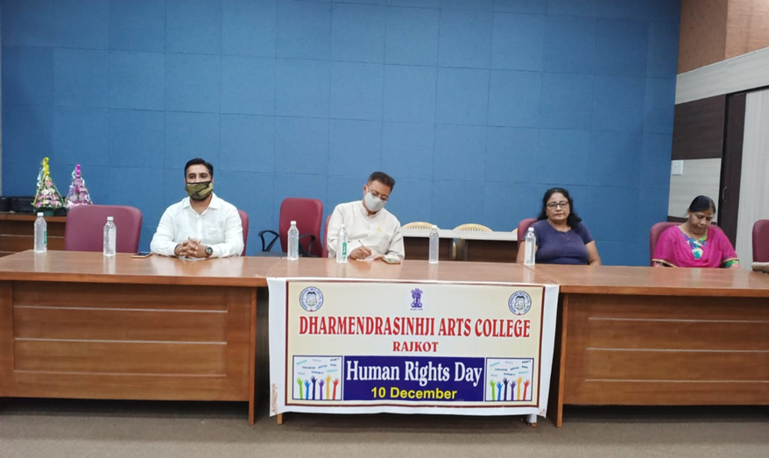

16/12/2020
Rashtriy Vijay Divas

Dharmendrasinhji Arts College, Rajkot conducted an online program to celebrate Rashtriya Vijay Divas on 16/12/2020 at 11:30am on Microsoft Teams. The function was arranged by the NSS committee and History Department. The students from all semesters joined this event virtually while all the professors attended the program in the auditorium of our college. Dr. J. D. Kanjariya- the senior faculty of History subject from Smt. R.R. Patel Mahila College, Rajkot was the chief guest of this event. This event was celebrated to remember the victory of our nation in 1971 against Pakistan. The program was handled by Dr. J. S. Upadhyay.

16/12/2020
Rashtriy Vijay Divas

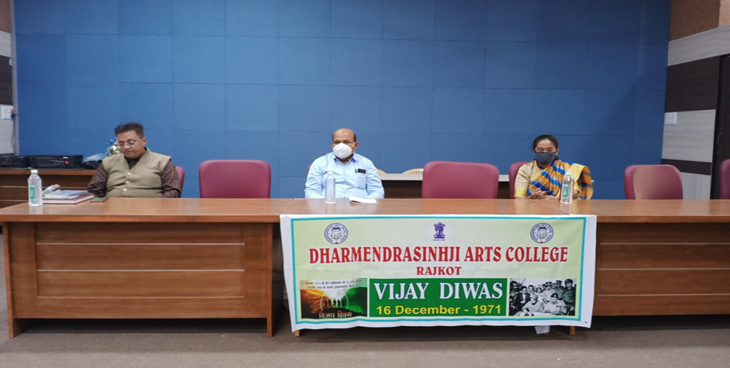

24/12/2020
National Consumer Day

Dharmendrasinhji Arts College, Rajkot celebrated National Consumer Day on 24/12/2020 at 11;30am with Microsoft Teams. The organisers of this virtual event were the NSS committee of our college and Rajkot District Grahak Suraksha Mandal. Mr. Ramjibhai Mavani, Mrs Ramaben Mavani, Dr.Viralbhai Pipalia- Consumer Right Activist and Professor and Dr. J.N. Gallani- Insurance-expert were the guests of the event. All of them gave very fruitful speeches on consumer rights and its actual application in day today life.

24/12/2020
National Consumer Day

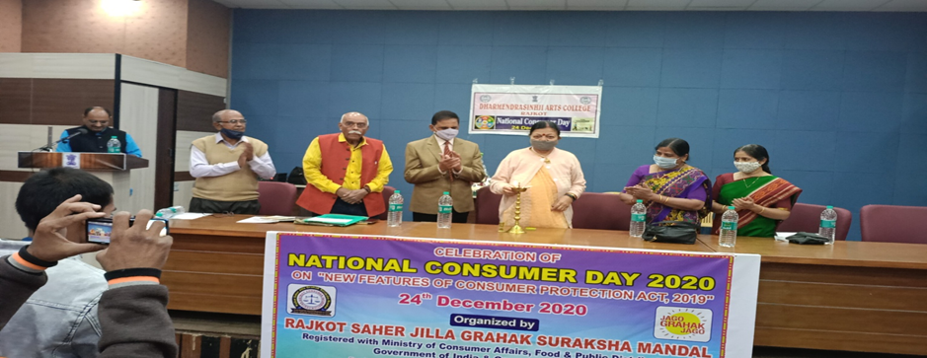

25/01/2021
National Voters Day
On 25/01/2021 Dharmendrasinhji Arts College, Rajkot celebrated National Voters Day. The program was organised to make undergraduates aware about the power and importance of votes in democracy. The college has also conducted a Voter awareness programme on 25/01/2021 for all the students to make them sensitised about their constitutional powers of voting. This day was celebrated with many interesting activities like Voters Awareness Speech, Elocution Competition, Drawing Competition and online MCQ test on Voters Awareness.Dr. A.S. Rathore - the principal delivered a highly informative speech on the awareness of Voters. Mr. Riteshkumar P. Patel, an assistant professor of Geography Department of our college gave a speech on the topic of ‘Election Process and Duties of Voters’

25/01/2021
National Voters Day

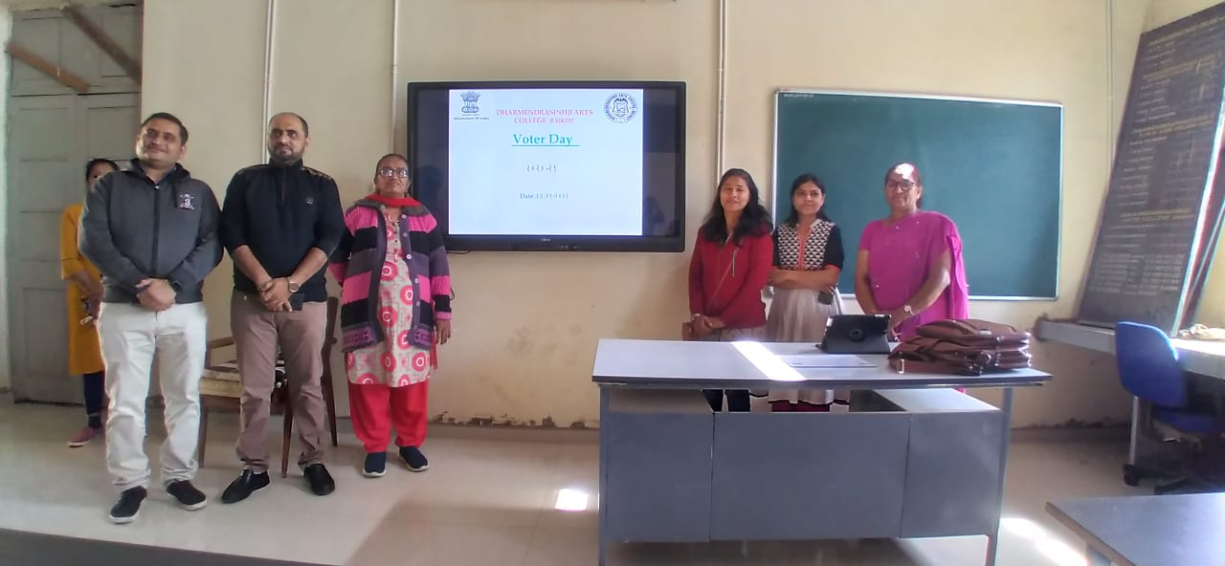

26/01/2021
Republic Day

Republic day is Celebrated on 26th January every year by organising activities highlighting the importance of the Indian Constitution. The NCC cadets performed a mindblowing parade. Dr. Girish Jadav anchored the whole program. Dr. Jagruti Vyas sang a melodious patriotic song. At last Dr. A.S. Rathore, the principal of Dharmendrasinhji Arts College delivered a speech on the importance of the Republic Day.
